Opening PDF Files on the TEA Public Website
If you are unable to open .PDF files on the TEA Public Website, please perform the following steps:
In the upper right hand corner of your Internet Explorer, click on the round settings wheel.
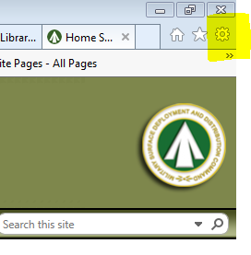
Click on “manage add-ons”
Find the header called “Adobe Systems, Incorporated” and then single click on “Adobe Acrobat SharePoint Open Documents Component. 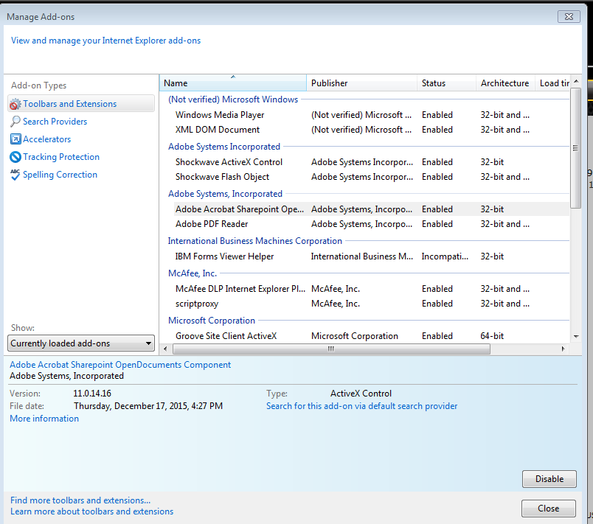
If “Adobe Systems, Incorporated” is not listed, click on “currently loaded add-ons” and change the view to “all add-ons”. Adobe Systems, Incorporated should be visible now.
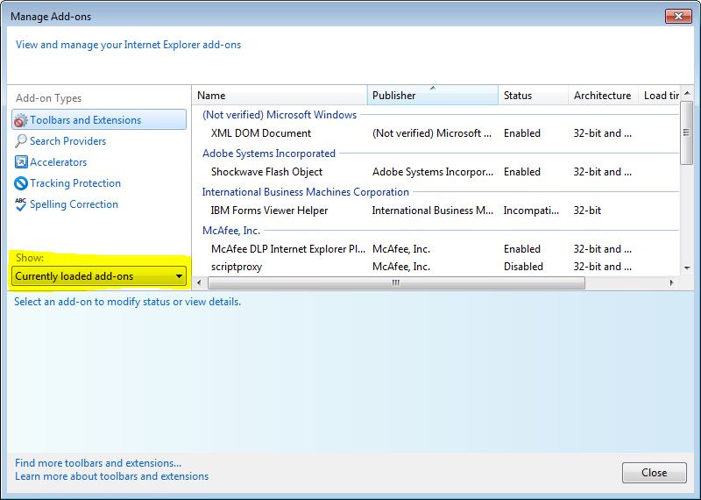
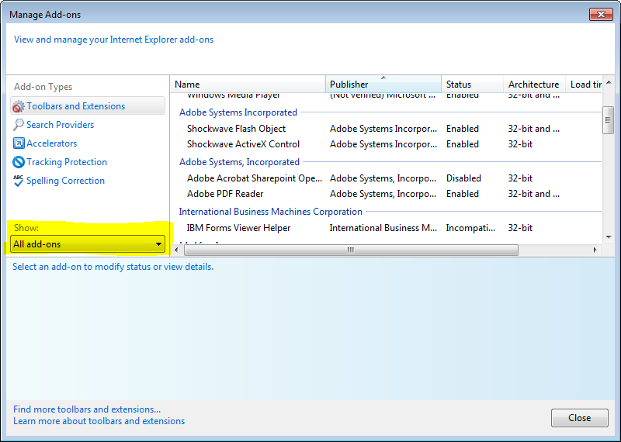

Then click on “disable” and then “close” in the lower right hand corner of that dialog screen
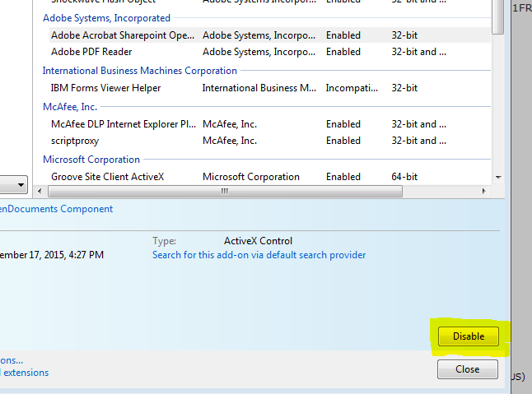
Refresh your Internet Explorer
Try to open your .PDF file again.
You should no longer be prompted to authenticate.

If you are still having issues accessing files on the TEA Public Web Site, please contact the SDDC Web Help Desk at 618-220-5190.

